Year 5 Preparation for Practice (PfP1)

Primary and preventative care

Tutor and student guide 2025-2026



Course Academic Lead: Dr. Miriam Dolan m.dolan@qub.ac.uk
GP Administrator: Ms. Eveline Burns gpadmin@qub.ac.uk

Associate Director, GP: Prof. Helen Reid helen.reid@qub.ac.uk

Contents
Welcome and outline of Preparation for Practice 1- Primary and Preventative care 3
Course aims and learning objectives for students 3
Learning activities 4
MyProgress 6
Attendance 7
Clinical encounters and management 8
Theme-Based Learning 10
Immediate Discharge Documents- audit 10
MiniCexs and Patient feedback 11
Tutor feedback 11
Overarching activities 12
Assessment and progress 13
Practicalities 13
Reminder about dates 14
Induction, organisation and timetabling 14
Additional online resources 16
GP Subdeanery 17
And finally… 18

Welcome and outline of Preparation for Practice 1- Primary and Preventative care
Welcome to the Year 5 PFP1 GP attachment. A massive thank you to GP tutors and their practices.
PFP1 is a 7-week final year attachment in a general practice setting. The main objective is to further develop and enhance the competencies already developed in primary care clinical attachments, especially during year 4’s longitudinal placement. In year 5 the focus will be on advanced skills and knowledge like dealing with multi-morbidity and complexity, disease prevention and health promotion, and applying the generalist approach for effective care delivery.
Students will be active members of the primary care team and will be encouraged to develop their independent practitioner skills through ‘hot seating’ thereby assessing, appraising and managing patients’ needs. Students will experience the broad spectrum of primary care cases; from emergency and same day care, to complex multi-morbidity, palliative care and presentations across the spectrum of illness and disease. They will also be looking at aspects related to population health.

Host Practices will find further useful information in the Practice Handbook accessible, along with many other resources, through our website https://www.qub.ac.uk/sites/qubgp/

Course aims and learning objectives for students
The whole year 5 course has integrated learning outcomes with the overall objective to prepare students for practice.
Year 5 begins with the Applied Knowledge Test (AKT) element of the Medical Licensing Assessment (MLA), therefore the focus in year 5 placements will be gaining practical experience. It is all very ‘hands-on’ and students are encouraged to increase their level of independence and exposure to complexity.
PfP1 aims to build upon students’ time in GP within Year 1 to 4. The learning outcomes for the GP curriculum are set out in Learning and Teaching General Practice and are summarised below. Some learning outcomes will be more relevant to Year 5 and are highlighted.

- Holistic care (the biopsychosocial model) (includes dealing with uncertainty, prescribing/ adherence/ polypharmacy/social prescribing)
- The physiology of holistic care (includes Persistent Physical symptoms/Medically Unexplained Symptoms)
- The doctor-patient relationship
- Communication with patients of all backgrounds
- Continuity of care and integrated care
- Long-term conditions in i) Diagnostic phase, ii) Maintenance phase, iii) End of life care
- Emergency conditions
- Multi-morbidity and complexity
- The social determinants of health
- Preventing disease and promoting health
- Medical ethics
- Effective delivery of care –The generalist approach, also includes sustainable healthcare

Learning activities
Opportunities will naturally vary between practices. However, spending seven weeks embedded within a practice should offer valuable insight into how to identify and make the most of learning opportunities, while also supporting and tracking development needs and progress.
The focus is on Preparation for Practice and there is no better way to do this by engaging with patient-facing activities which in GP often means consulting directly with patients. Students should be given opportunities to assess patients with direct or indirect one-to-one supervision and the ratio of face-to-face versus remote consultations should be in-keeping with how the practice is consulting. Students should usually ‘sit in’ (in person, or on a three-way phone call) with a GP initially, but very quickly should start consulting with patients on their own before presenting each patient to the GP.
There will be some compulsory elements during the attachment, and these should be combined with the personal learning needs of the student.

Examples of learning activities (see also Learning General Practice digital textbook for interesting, wide-ranging suggestions):
- ‘Hot seating’- see selected or unselected undifferentiated presentations under decreasing levels of supervision
- Complete medical records (as per agreed format with the tutor) after assessing a patient
- Work alongside the ‘doctor on call’/’duty doctor’ and be actively involved in assessing more urgent presentations and interfacing with secondary care/the multi-disciplinary team
- See patients presenting with multiple issues or complex issues like chronic pain or frailty
- Reflect on management options and how to best discuss these in a shared-decision, person-centred way
- Get involved in pre-prescribing
- Review patients after organising further investigations
- Review patients after a few weeks to see how the shared management plan is working out
- Be involved with patients with diagnostic or other uncertainty and/or (medically unexplained) persistent physical symptoms
- Pro-actively review patients with more complex or multiple issues and explore the value and effectiveness of relationship-based care
- Consider ‘hot seating’ after active observation of the practice nurse or GP-pharmacist to enhance your ability to manage long term conditions and multimorbidity
- Get involved in optimalisation of medications, reviewing patients with problematic polypharmacy and deprescribing etc.
- Be involved in home visits – seeing patients in their ‘real-life’ contexts offers a unique perspective. This can be same day visits, routine visits or pre-selected home visits. There is more detailed guidance for practices around practicalities of home visits
- Arrange follow up after a recent admission – the patient journey (part of Theme-based learning)– first read all the correspondence relating to the admission, arrange to visit the patient at home to interview the patient and to hear their “story” of their “journey” and discuss it with your tutor and in your online small group session
- Reflect on learning activities within the MyProgress platform which includes identifying and preparing your cases for Theme-Based Learning
- Identify a palliative care patient and be part of the team caring for the patient during the 7-week placement (see also Clinical encounters)
- Identify selected patient(s) known to the GP with significant diagnoses. Students could review their records +/- contact them and review them (in practice or at home)
- Attend tutorials for GP trainee(s) or GPNI webinars/Practice Based Learning
- Attend a Child Protection Case conference or be pro-active in getting involved with a family receiving additional support (e.g. through the Health Visitor)
- Asynchronous learning activities (see additional online resources)

MyProgress
MyProgress is the platform students use to record, track and reflect on their learning. Training resources on practical use of MyProgress and a FAQ form are available on the QUBGP website. It is a student’s responsibility to ensure that all required elements of MyProgress are completed, and they may prompt tutors about when and what needs completing. Students will need to ask their GP tutor(s) for a preferred email address – entering this will enable tutors to access the MyProgress platform and access the forms and view the students’ progress. It is important the email address is entered correctly by the student. There is an option to add additional supervisors if required.

As patients present with a multitude of issues, often undifferentiated and unselected, often with a bio-medical and psycho-social aspect, grounded within their own specific individual context and health belief system, it would be unhelpful to ask students to be disease-specific or ‘tick-box’ through a list of conditions. The compulsory elements for PfP1 documented on MyProgress are therefore based on real patient encounters, and clinical experiences encompassing aspects like multi-disciplinary assessment and person-centred management plans, at times requiring GP and patient feedback, but mainly achieved through self-reflection and/or peer-supported engagement.

MyProgress PfP1:
Learning activity | How many? | Signed off by:
Attendance | 100% | Student
Clinical encounters and management | 4 | Student
Theme-based learning | 5 | Student
IDD audit | 1 form | Student
MiniCex and Patient feedback | 2 | GP tutor
Tutor feedback | 2 | GP tutor

Attendance
Medical School regulations mandate 100% attendance for all years. There will be mitigating circumstances for non-attendance such as ill health or prospectively requested leave. Students submit all prospective leave requests in advance (including for up to two days’ ‘discretionary leave’ across each academic year) and are encouraged to clearly communicate any approved leave requests with supervising clinical teams. Practices are asked to advise the student how to contact the practice (e.g. using the direct line into the practice or the practice manager’s email) in unlikely circumstances they can’t come in due to e.g. ill health. Further details around attendance and absence policies are available on the QUB Medical Education portal.
A feature of the MyProgress system is attendance monitoring – daily in secondary care (and at all times for students holding Tier 4 Visas) and weekly while on GP placement. The system generates an automated email to the designated email address. No action is required if the student was present; the email advises what to do in the unlikely event that this was not the case. If a student doesn’t show up unannounced contact gpadmin@qub.ac.uk

Clinical encounters and management
Clinical encounters with patients are a core activity of GP, and as such students are likely be involved in hundreds of GP clinical encounters over their medical school career. A clinical encounter can range from active observation to full active participation or even leading the consultation (see Box 1). In year 5 students are expected to mostly lead the consultation. The complexity of these encounters may vary from straightforward linear cases, such as a patient presenting with one single issue like an acute cough (low complexity) to highly complex cases, such as an elderly patient with multiple chronic conditions and a multitude of bio-psycho-social challenges. Students are expected to demonstrate increasing competency over the 3 years in General Practice. In Year 5 they should actively seek out clinical encounters of greater complexity and aim to achieve higher Entrustable Professional Activities scores (see Box 2).
Throughout the GP placements in Years 3, 4, and 5 students will record a set number of clinical encounters on MyProgress: two in Year 3, four during each two-week placement in Year 4 and four in Year 5. In Year 5 students are expected to reflect on 4 specific clinical encounters:
- One focused on emergency or acute care
- One involving long-term conditions or multi-morbidity
- One related to palliative care
- One encounter that provided meaningful learning about relationship-based care
Students are also required to discuss aspects of the clinical management in each of these encounters.
Box 1
Active observation, active participation and leading the consultation

Active observation
Observation is not a passive process - it offers opportunities for active learning
Active participation
Initially students might ‘hotseat’ an element of a consultation – ‘information gathering’, or an aspect of a focused examination or be ‘delegated’ elements of management
Leading consultations
This may be with a GP in the room or in another consulting room (space dependent) –a student is leading a consultation (face-to-face or remote if they are working through from initial information gathering/examination to formulating some kind of ‘next steps’ as to how the consultation might conclude. In year 5 this includes moving beyond history and examination to ‘the second part of the consultation’ and consider management approaches.

Box 2
Entrustable Professional Activity (EPA) scale:

- First introduction: observing only
- Working together with supervisor: co-activity
- Supervisor steps in as needed: direct supervision
- Supervisor in the background: direct supervision
- Supervisor in adjacent room and checks work at the end: indirect supervision
- Supervisor in adjacent room and checks key aspects of work: indirect supervision
- Supervisor at a distance but available by phone: indirect supervision
- Fully independent consulting.

All year 5 students are expected to have progressed beyond level 4-5 by the end of Year 5.

Theme-Based Learning
The PfP1 placement provides students with unique opportunities to increase their understanding of wider, context-determined elements of individual and population health, and complexity and uncertainty in illness and disease. This will be facilitated through Theme-Based Learning. Students will collect five cases which will be shared with peers during a weekly small group session facilitated by the General Practice Subdeanery. The online group sessions will be on a Wednesday or Thursday afternoon and the students will receive an email with more information on when and how to attend online. 100% attendance is expected.

The themes that will be explored using real cases are:
- The social determinants of health and health inequalities
- Chronic pain (with Versus Arthritis and an expert patient)
- Uncertainty and Persistent physical symptoms
- Overdiagnosis, ‘too much medicine’
- The patient journey through primary and secondary care

If the student hasn’t encountered a case touching on the specified themes they can use a Virtual Primary Care case- these are listed in a supplementary document on Theme-based learning which you can find on the QUB portal.
Remember that there is more learning in writing up a case in a reflective way instead of just describing the case: the why instead of the what question.

Immediate Discharge Documents- audit
IDDs (Immediate Discharge Documents) are an important method for onward care of patients being discharged from hospital. GAIN has produced guidelines on IDDs. Clinical Audit is an important approach to check adherence to best standards. In this IDD Audit the students will be contributing as Pre-Foundation students in partnership with Regulation and Quality Improvement Authority and the Trusts, to conduct an annual at-scale region-wide snapshot. This is educational for the students and will identify targets for further Quality Improvement work in our local Health Service. This is also an opportunity to highlight good practice and to improve current practices for F1s and Trusts and through this to improve patient safety. Published findings (2017) of this audit can be found HERE.
Instructions for the students:
Fill in an audit form of 5 consecutive IDDs every week (preferable before any medication changes have been updated)
Get a printout of the pre-admission medication and compare medication records before admission and after discharge
Print off or open the Audit Proforma available on the portal and collate the data for the 5 discharges each week
Transcribe the audit data onto the online form – please do this at one sitting. Link to the form can be found on the QUB portal and under IDD audit on MyProgress.

At the end of the placement, the student will discuss their findings with their GP tutor and/or the practice-based pharmacist (GPP). They will complete the relevant section of the MyProgress form, addressing the following questions:

Were the audit standards met?

What changes would you suggest to improve adherence to audit standards?

How will this experience influence the way you prepare IDDs (Immediate Discharge Documents)?

The students will also share their findings and reflections with peers during a TBL (Team-Based Learning) session.

MiniCexs and Patient feedback
The mini-clinical evaluation exercise (mini-CEX) is a formative assessment tool and part of the student’s work-place-based assessment. It is designed to provide feedback on skills essential to good medical care by observing an actual clinical encounter. It facilitates the receiving of constructive feedback. Providing written feedback by answering the open-ended questions ‘Anything especially good?’ and ‘Suggestions for development’ is highly valued by students.
During the PfP1 placement students will be filling in two MiniCex forms, one at the start of the placement and one at the end, as this will make them reflect on the progress they have made.
The tutor will also ask the patient to give feedback (not witnessed by student). The GP/ tutor will ask the patient ‘How likely (between 0 (very unlikely) and 5 (very likely) is it you would want to see the medial student again and why?’ and will discuss this with the student after the patient leaves. Patient feedback is helpful in highlighting potential areas for further professional development.

Students are encouraged to continuously seek constructive feedback outside the MiniCexs.

Tutor feedback
Towards the mid-point and the end of the PfP1 attachment, students should arrange a review with their GP Tutor to discuss progression. The feedback is part of the students’ work-place based assessment. Tutors should fill in the free text box as well as ticking the template which assesses adaptive and flexible consultation skills, clinical knowledge and skills, approach to patient management, responsiveness to teaching and enthusiasm for learning, appreciation of risk, uncertainty and complexity and professionalism (incl. punctuality, teamworking). The forms can be found under ‘supervision’ on MyProgress. The GP tutor can use the box at the bottom of the form for any questions, concerns or challenges. This will initially be dealt with by the QUB GP team. If there are more immediate concerns, contact gpadmin@qub.ac.uk or m.dolan@qub.ac.uk. The student is asked to reflect on the end-of-placement feedback using a separate form on MyProgress.

Overarching activities
The whole year 5 course has interconnected learning outcomes. Some learning activities will cross over the various placements.
All students are expected to be involved in a Sustainability in Quality Improvement project as this is mandatory as per GMC requirements. Some will do this in PfP1 either choosing their own subject or getting involved with an ‘off the shelf’ project. It is student-led and QUB supported. Students will be instructed on how to go about it. Students will have to discuss their proposal briefly with the tutor if they plan to do it in GP agreeing on timeline and impact feasibility at the very start. There will be no expectation on tutors and practices to provide repeated advice or supervision of the project; it is student-lead with advice from year 5 lead in QUB.
During year 5 students are involved in pre-prescribing, also called Purple Pen. Prescribing is a common task, often performed by junior clinicians, with potential for significant harm. With appropriate support, tutors can create ‘safe fails’ by letting students write prescriptions for real patients. In General Practice it is recommended the student write and print a script using a Dummy patient after assessing a patient needing a pharmacological intervention or when practicing other prescribing decisions which can be discussed and reviewed by the tutor/supervisor. Students appreciate getting involved in prescribing especially if the Prescribing Safety Assessment exam is coming up.
Recognising and dealing with the acutely ill patient, being ‘on-duty’ and Holding the Bleep is another overarching theme in the PfP 1-2-3 placements which can be facilitated in General Practice by scheduling the student to work alongside the doctor responsible for dealing with urgent situations on the day.
Anybody supervising a student doing a specific procedure during their PfP1 placement could be asked to sign off on a GMC23 Practical Skills and Procedures.

Assessment and progress
From 2024 onwards, all medical students graduating from UK universities need to pass a national exam – the Medical Licensing Assessment (MLA). This entry requirement for inclusion on the medical register by the General Medical Council incorporates both written and practical components. When Year 5 students start their placement, they all sat their MLA Applied Knowledge Test (AKT) – ‘written finals’. The exam still outstanding is the Clinical and Professional Skills Assessment (CPSA) (March 26). The PfP1 placement offers ideal opportunities to practice for Observed Structured Clinical Examinations (OSCEs) by actively being involved in patient-facing activities. Further information on the MLA exam can be found HERE.

During the PfP1 placement it is important to focus on progression. As students have spent 8 weeks in GP in Year 4, they would want to challenge themselves and be challenged which can be achieved by adapting the students’ learning activities. MyProgress can help in that it asks students to score themselves regarding EPA level (Box 2) and complexity. The level of complexity is scored between 0 (not complex) and 10 (very complex) taking into consideration symptom complexity, complexity of findings on clinical assessment and of investigations, socioeconomic/behavioural challenges, diagnostic and management complexity.

An example of how this could be facilitated:
Week 1-2: Student surgeries including long-term conditions (LTC) reviews and triage - EPA levels 1-2, complexity score 0-3
Week 3-5: Student surgeries including LTC reviews and triage -EPA levels 3-4, complexity score 4-7
Week 5-7: Student surgeries including LTC reviews and triage - EPA levels 6-7, complexity score 8-10 but possibly lower EPA for higher complexity score

Practicalities
Students are asked to ensure they’ve contacted the practice before their initial arrival. As a teaching practice you could consider contacting the student(s) before they start; students really appreciate this. Students value being welcomed by name and having a timetable for their placement on day one.

Reminder about dates
Students are in practice 7 weeks out of a block of 8 weeks. In week 2 or 3, after starting their placement, they will be scheduled for a week for Self-Directed Learning or to attend the Human Health Factor course on Campus. They will not be in practice during this week.
One slot a week (1.5 hours) students will attend an online GPSD-supported TBL group session and one session a week should be reserved for self-directed-learning including time for their SusQI project.

Induction, organisation and timetabling
Students appreciate and benefit from a comprehensive induction and orientation to the practice and a timetable.
Recommended areas to cover during induction:
- Done
Introduction to key staff members, specify who the main tutor is and a tour of the premises
Brief overview of practice: population size, computer system, appointment system
Show where students can leave their coat, bag and belongings
Facilities such as the toilets and any area for breaks/storing food etc.
Any important safety issues e.g. fire escape routes, personal safety alarms/alarm button
Clarity around contact – what is the best phone/email address for students to use if they can’t come in due to illness
Any student special circumstances / disabilities that are relevant for the GP tutor (and practice) to know about
Any practice specific protocols around clinical clothing (any preference for scrubs or ‘normal clothes’?)
If possible, unique student GP computer system logins, which encourages ownership and transparency. Some practices let students use the login of the tutor, but clearly state during the induction that the student must write in the clinical records the patient was initially assessed by them, the name of who supervised them and that the notes were written by them and checked by the supervisor
Computer system: allow some time to get used to the clinical system and explain what is expected when they write clinical notes
Advice around access to WiFi so that students can support their learning using their own devices where possible. BSO WiFi access should be possible for most practices
Where/how students can record details of and organise patient reviews by themselves or by the team
Remind them of the importance of confidentiality- students follow GMC GMP guidance for students
Check their familiarity with ECR and ENCOMPASS including issues around confidentiality, GDPR and the vital importance of only accessing information relevant to patient care; never their own/known individuals’ records
Discuss what they are hoping to get out of the placement (personal development needs) and what compulsory elements are involved and how they are hoping to achieve them
Go over expected professional behaviours like introducing themselves by name and role to the patient, kindness, respect and curtesy, teamwork etc. (see Good Medical Practice (GMP) for medical students
Detail procedures and policies important for the placement including home visit guidance, consent and chaperone policy, child and adult safeguarding policy etc.
Explain patients appreciate
- that students add value to the care patients receive e.g. by having delegated tasks like following patients up after a test or consult
- when students are transparent about their knowledge gaps
- when students listen attentively
- being involved in their teaching by sharing their lived experiences
- being pre-warned when they are seeing a student
- being involved in the feedback process to help their learning

Students are helped by having a timetable of activities across the 7-week placement. This allows students to structure their attachment and learning.
The below is simply an example of how week 4 in the 7-week attachment could look like.
It is advised the student knows who the supervising doctor is for each day.
Week 4 | Morning | Afternoon
Monday | Student surgery (undifferentiated)  Supervision: | Discharges (IDD) and clinical encounters related to results/reviews  Supervision:
Tuesday | Student surgery (undifferentiated)  Supervision: | Student surgery (complex, routine)  Supervision:
Wednesday | LTC student surgery  Supervision: | Theme-based learning and self-directed learning including QI project  Supervision:
Thursday | Triage  Supervision: | Emergency care with Duty doctor  Supervision:
Friday | Student surgery (selected e.g. multi-morbidity and reviews)  Supervision: | Home visits  Supervision:

Additional online resources
Students are provided with a range of online learning resources on the QUB Medical Education Portal. Tutors do not require access to this Portal, though you can register for access should you wish. The already mentioned Learning General Practice digital textbook is a really helpful resource for both students and tutors.

In Year 5 the Virtual Primary Care (VPC) resource can be used for additional learning as well as for case submission on MyProgress for Theme-based Learning if the student hasn’t be able to identify a suitable case. There is a list of suitable VPC cases included in the supplementary document on TBL on the portal for this purpose. All students have access to VPC. If any GP colleague would like access to this resource, please get in touch with gpadmin@qub.ac.uk providing your hscni email address (unfortunately the system will not grant access to any other personal emails).

Other available resources:
Capsule is a case-based online resource produced as a collaboration across UK medical schools. Students have access to a vast range of cases and quizzes with feedback and further links – with the material pitched at a great level for them. There are around 40 GP cases (some relatively short, others which might take students 45-60 minutes to work through). While some students may elect to work through the cases in their own self-directed way, they are likely to maximise their learning if GP tutors are able to signpost them to cases covering areas that they had perhaps not had any exposure to, or following on from a specific consultation.
If a tutor would like personal access to Capsule, we can try to facilitate personalised logins etc. Please email gpadmin@qub.ac.uk explaining that you are a GP tutor, and we will try to make the necessary arrangements.

GP Subdeanery
The GP subdeanery (GPSD) is a new and essential partner to General Practice teams and the two universities in Northern Ireland. They state on their website (2025): 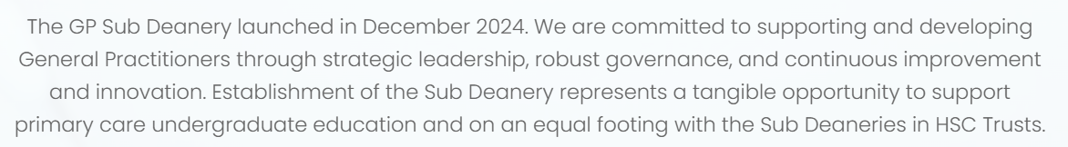
The goals and resources of the GPSD are available HERE.
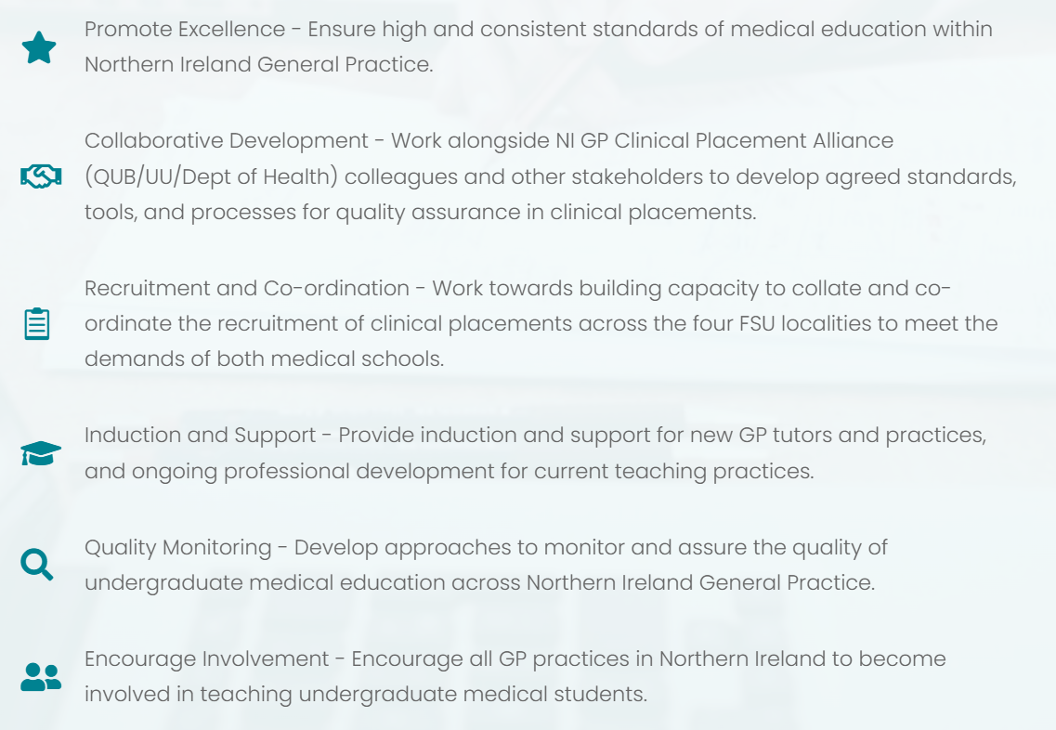
Community Module Leads, who work as part of the GPSD team, are General Practitioners with a range of clinical and educational expertise. They currently support the general practice learning of medical students through the co-facilitation of small group learning in Y4 Case Based Learning (CBL) and Y5 Team Based Learning (TBL) and MyProgress review across Y3-5.
If you have any queries about how to best support the GP learning of medical students in general Contact - GP Sub Deanery. For concerns relating to an individual learner, please contact the QUB Year Lead and gpadmin@qub.ac.uk.

And finally…
Please don’t hesitate to contact us (initially at gpadmin@qub.ac.uk) if you encounter any challenges or with any suggestions on improving the course. We would appreciate your ideas for development.

Many thanks again to all the tutors and teaching practices.

Miriam Dolan

